REGISTRATION 2020
Welcome to Russell Vale Junior Football Club

The Committee of Russell Vale JFC welcome you to register with us for the 2020 season.

New players are always welcome.
Please ensure you register for the age you are turning in 2020.
After completing the registration form you are required to attend one of the following registration dates at Cawley Park Clubhouse, Russell Vale with your invoice and cash to pay for the registration, after registering online (DO NOT PAY ONLINE):
Saturday 1st February – 10am to 2pm
Saturday 8th February – 10am to 2pm
If you are not using an Active Kids Voucher, then payment of the following is required to be paid on the Registration Day: -  $110 for U6 - U7  $125 for U8 - U9  $150 for U10 - U17 | If you use an Active Kids Voucher, then payment of the following is required to be paid on the Registration Day: -  $10 for U6 - U7  $25 for U8 - U9  $50 for U10 - U17

- Open; playfootball.com.au,
- Note:- If you want to apply for the Active Kids Voucher the Website is service.nsw.gov.au
- Click on ‘REGISTER NOW’ under ‘FIND YOUR TEAM’
- Select either ‘Age 5-11’ (U6-11) OR ‘Age 12-18’ (U12-17), whichever is appropriate
- Type in ‘Russell Vale’
- Select ‘Russell Vale Junior Football Club’
- No need to contact club
- Select ‘START MY REGISTRATION’ (bottom right of page)
- Select ‘Get Started’
- You will need to create a new parent account, fill in details, accept T & C’s, Register
- You will be sent an email with verification code, enter code, continue
- Enter your password, continue
- If you have previous accounts you can now link them, continue
- Then complete all other relevant information
Any problems email me at RVJFC1954@gmail.com

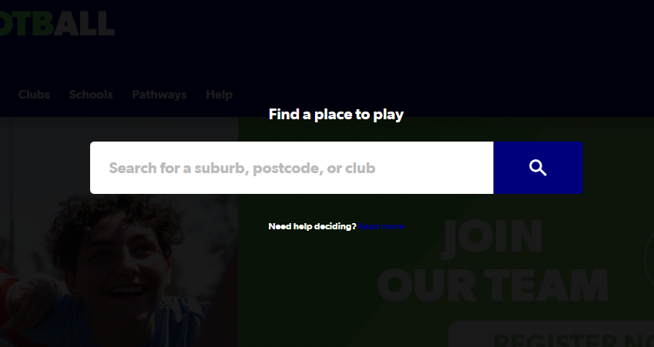

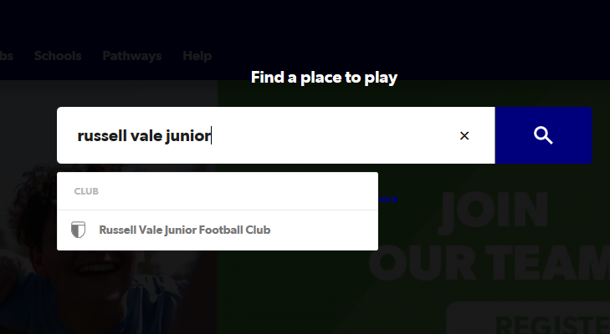
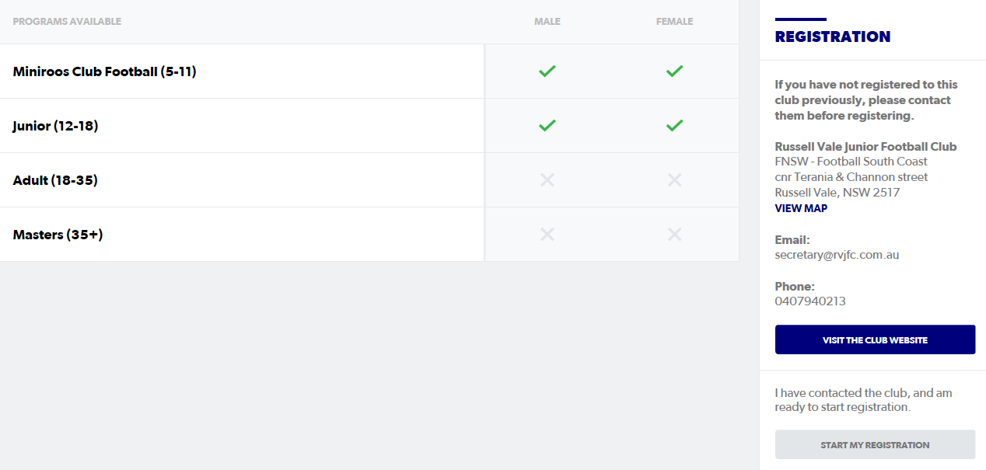

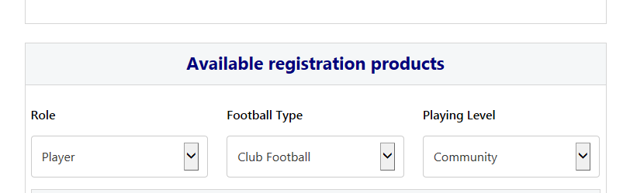
Then add Child and Parent details.

